**1** **a)** Identify the points A, B, C and D on the diagram. (4)

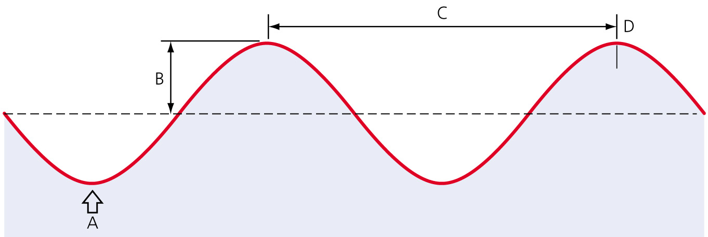

**b)** If the frequency of the diagram shown above is 300 Hz and the wavelength is 1 m, what is the wave speed? (2)

**2** Julia and Marco stand at opposite sides of a small valley.

Z:\01-Word\01-Download\12_DEC\27\Physics\Creative_Art\HTT_4.6_02.eps

They want to determine the speed of sound. Marco fires a starting pistol. The pistol emits a puff of smoke when fired. Julia has a stop watch and starts the watch as soon as she sees the smoke. She stops the watch when she hears the sound of the gun. Julia and Marco repeat the exercise five times. They collect the following data.

|  |  |
| --- | --- |
| Trial | Time taken to hear sound  (s) |
| 1 | 2.9 |
| 2 | 3.0 |
| 3 | 2.9 |
| 4 | 3.1 |
| 5 | 3.1 |

**a)** What is the average time taken between Julia seeing the smoke and hearing the pistol fire? (2)

**b)** Calculate the speed of sound from Julia and Marco’s data. Express your answer in m/s. (2)

**3** When waves travel from one medium to another, the frequency stays the same.

The diagram shows sound waves travelling at 330 m/s in air.

Z:\01-Word\01-Download\12_DEC\27\Physics\Tech_Art\HTT_4.6_03.eps

**a)** What happens to *λ* as the sound wave travels through the carbon dioxide? Sound travels at 270 m/s in carbon dioxide. Give a reason for your answer. (2)

**b)** If *λ* = 2 m:

**i)** what is the frequency of the sound wave in air? (2)

**ii)** what is the frequency of sound waves in carbon dioxide? (2)

**iii)** what is the wavelength of sound waves in carbon dioxide? (2)

**4** An ultrasound scanner is being used to investigate the health of a patient’s kidney. The speed of the ultrasound is 1500 m/s and the frequency is 5 MHz.

Calculate the wavelength of the ultrasound. Express your answer in mm. (2)

**5 a)** **i)** Name two types of wave that have a shorter wavelength than visible light. (2)

**ii)** Name two types of wave that have a longer wavelength than visible light. (2)

**b)** BBC Radio 4 is transmitted at a frequency of 93.5 MHz. What wavelength is this?

(Assume that the speed of transmission is 3 × 108 m/s.) (2)

**c)** Approximately how long would it take a radio wave transmission from the Mars rover to reach mission control on earth? Mars is 36 million kilometres away. Express your answer in seconds.

(Assume that the speed of travel is 3 × 108 m/s.) (2)

**6** A normal plane bedroom mirror reflects electromagnetic radiation in the visible part of the spectrum. This means that an image will be seen in the mirror.

**a)** Jasmine stands in front of her bedroom mirror. It is a plane mirror and she stands 2 m away. The bedroom door is 2 m behind her. How far away does the virtual image of the bedroom door appear to be? (1)

**b)** Which of the following types of radiation will be mostly reflected in the mirror?

**A** Infrared

**B** X-ray

**C** Gamma ray

**D** Microwave (2)

**7** **a)** When a dentist takes an X-ray of teeth, he usually leaves the room. Explain why this is necessary. (2)

**b)** When food is cooked in an electric oven, what type of radiation is cooking the food? (1)

**c)** Food can be cooked by microwaves in a microwave oven. Mobile phones also transmit and receive microwaves. Explain why we are not cooked when using our mobile phones. (2)

**8** **a)** Draw a diagram to show:

**i)** a convex lens.

**ii)** a concave lens. (2)

**b) i)** Complete the diagram to show parallel light rays being brought to a focal point after exiting the lens. (2)

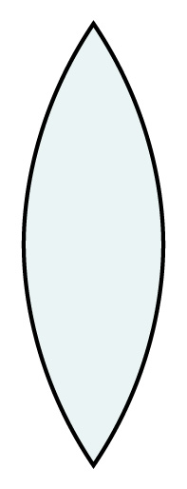

**ii)** Draw and label the focal length in the diagram. (1)

**iii)** Is the image of the focal point formed by this lens real or virtual? (1)

**9** The magnification produced by a pair of binoculars = 

**a)** What are the units of magnification? (1)

**b)** A pair of binoculars is said to have a magnification of 30×.

**i)** What is meant by this? (1)

**ii)** If you use the binoculars to watch a ship that is 3 km away, calculate how far away will the ship appear in the binoculars? Express your answer in m. (1)

**10** **a)** The Earth and atmosphere are warmed by the Sun’s radiation. Explain why you feel colder on a cloudy summer day than on a cloudless day. (2)

**b)** Explain why people are advised to wear a sun screen on sunny summer days but not necessarily on sunny winter days. (2)

**11** In the diagram, white light is shone onto a surface.

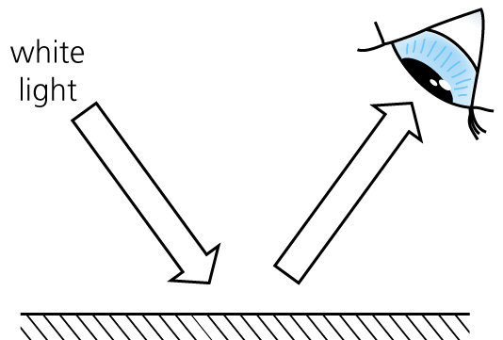

**a)** If the surface reflects all wavelengths of light equally, what colour will it appear? (1)

**b)** If all wavelengths are absorbed by the surface, what colour will that appear? (1)

**c)** If all colours except blue are absorbed, what colour will the surface appear? (1)

**d)** Why are plant leaves green? (1)

TOTAL = 53

**1 a)** A = trough;B = amplitude; C = wavelength; D = peak (4)

**b)** Wave speed = frequency × wavelength; = 300 × 1 = 300 m/s (2)

**2** **a)** Mean of times = 3.0 s (2)

**b)** Speed = distance/time; = 1.05 × 103  = 350 m/s (2)

**3** **a)** The frequency stays the same, therefore *λ* must decrease as the speed is lower in carbon dioxide. (2)

**b)** **i)** Speed = *fλ*; *f* =  = = 165 Hz. (2)

**ii)** 165 Hz. They have the same frequency in air and carbon dioxide (2)

**iii)** *λ* = =  = 1.636 m (2)

**4** Speed = *fλ*;

*λ* = = 0.3 mm (2)

**5 a)** **i)** Any two from gamma ray, X-ray, ultra violet. (2)

**ii)** Any two from infrared, microwave, radio wave. (2)

**b)** Wavelength = = 3.21 m (2)

**c)** Time =  = = 120 s (2)

**6** **a)** 6 m (1)

**b)** **A** Infrared

**D** Microwaves (2)

**7** **a)** X-rays are penetrating radiation and are dangerous to humans. Exposure to X-rays should be limited; it is safe for the patient to have a one off X-ray; the dentist should not be continually exposed to the X-rays of all his patients. (2)

**b)** Infrared (1)

**c)** The wavelength of the microwaves used to cook food is very different from the wavelength of microwaves used to transmit and receive a mobile phone signal. The mobile phone microwaves would be useless in a microwave oven. (2)

**8** **a)** **i)**



**ii)**

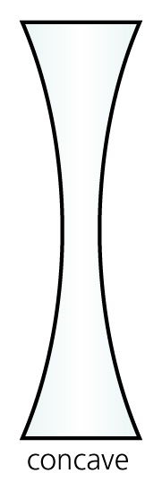 (2)

**b)** **i)**

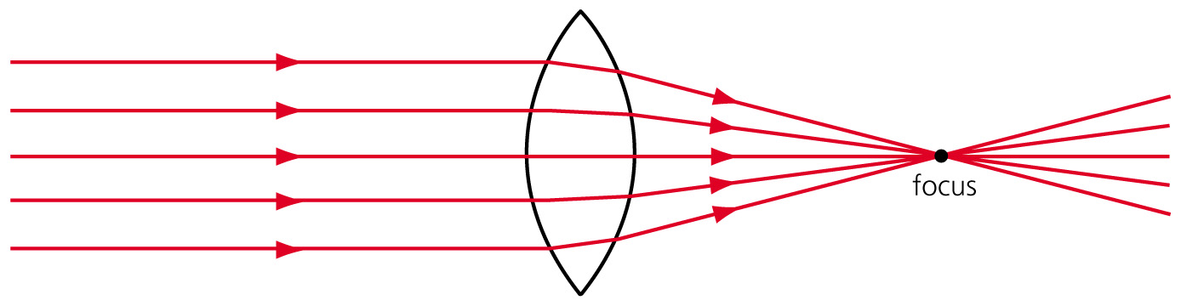 (2)

**ii)**

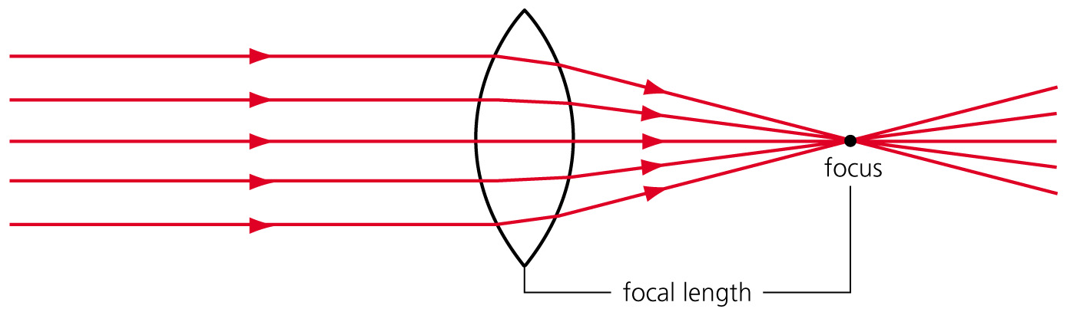 (1)

**iii)** Real (1)

**9 a)** It has no units as it is just a ratio. (1)

**b)** **i)** The image is magnified or enlarged 30 times when viewed through the binoculars. (1)

**ii)**  = 100 m (1)

**10** **a)** The cloud reduces the amount of the Sun’s radiation falling on you; this reduces the heat from sun and you feel colder. (2)

**b)** The Sun is closer to the Earth in the summer, so the radiation and consequent burning effect on the skin is higher than in winter when the Sun is further away. (2)

**11 a)** White (1)

**b)** Black (1)

**c)** Blue (1)

**d)** They reflect green light and absorb all other wavelengths. (1)

TOTAL = 53